Northside High School 2019-2020
GSE Geometry

Teacher: Coach Buchanan E-mail: Buchanan.david.w@muscogee.k12.ga.us
Class: GSE Geometry Room: 914

Textbook: HMH Geometry Common Core Edition (all students will have online access/actual book optional)
Suggested Requirement: Scientific Calculator (for home)

CLASS WEBSITE: NHSBUCHANAN.WEEBLY.COM

Unit 1: Transformations in the Coordinate Plane
Unit 2: Similarity, Congruence, and Proofs
Unit 3: Right Triangle Trigonometry
Unit 4: Circles and Volume
Unit 5: Geometric and Algebraic Connections
Unit 6: Applications of Probability

Class Policies and Expectations:
1). Students are expected to be familiar with and adhere to all rules and regulations of the Muscogee County School District Policies.
- Be in assigned seat when bell rings and remain there unless other permission is granted. Use issued class pass if you need to leave during class for any reason.
- Bring necessary materials to class (notebook with paper, pencil, and dividers).
- Respect rights of other students, your teacher, and administrators. Raise your hand if you have a question or something to say.
- Respect school property and furnishings.
- Be responsible for yourself. Honesty is expected.
- CELL PHONE: You are not to be using your cell phone during time that the teacher is addressing the entire class (during a lesson, while going over HW, etc.). Failure to cooperate will result in a warning and eventually a consequence at my discretion.

Students who are not able to adhere to the rules will be assigned detention. Detentions will be served from 7:30-8:00am or 3:30-4:00pm in room 914. The day will be decided by the teacher. Your transportation will be your responsibility to figure out.

2). Attendance: Good attendance is encouraged and expected. A loss of credit occurs when a student misses more than 15 days of class. Please see NHS handbook for a breakdown of the attendance policy.

3). Tardiness: A student is considered tardy when they are not inside the classroom when the bell rings. Consequences: 1 - 2 = warning, 3 – 5 = central detention, 6+ = office referral (ISS)

4). Prepared and Organized: Students are expected to come to class to learn.
Daily requirements include:
  - 3 ring binder (with paper and dividers)
  - pencil
5). Make up Work: Students have three days to make arrangements for work missed due to any excused absence. Students are responsible for getting the assignment and/or making arrangements for after school testing. Failure to make up work will result in a grade of zero on the assignment or test. Being absent the school day before a previously scheduled test does not excuse the student from taking the test on time. Advanced notice of testing will be given. Work missed from an unexcused absence is an automatic zero in the gradebook.

6). Progress Reports: Each student will receive a progress report at the middle of each nine weeks period. Additional progress reports can be accessed through Infinite Campus parent/student portals.

7). Extra Help: Additional assistance is available before or after school for those students who are showing initiative to learn in class. This time should be agreed upon in advance by student and teacher. Don’t just show up one day and expect me to have time without prior scheduling.

8.) Grading Procedures: Total Points - 100% of the grade is determined by quizzes, exams, performance tasks, and classwork/homework assignments.
During the grading period, quizzes, tests and tasks will be scheduled according to the material covered. Students may be periodically given a grade for information in their notebooks since it is essential to have a well-organized notebook in math class. GSE Geometry is a required course for students to complete graduation requirements.
***This course has a GA Milestone End of Course Exam. This will be calculated as 20% of the Final Grade as mandated by the state of Georgia.***

Academic Honesty Policy

The following statement will be written on every quiz and test, plus any other assignment specifically requested by the teacher. By writing this statement, the student is acknowledging that they completed the task without unauthorized assistance. This can include but is not limited to: copying from a classmate, using a cell phone, using a “cheat sheet”, etc.
“I completed this assignment without giving or receiving unauthorized help, thereby maintaining my integrity.”

The consequences giving or receiving unauthorized assistance are:
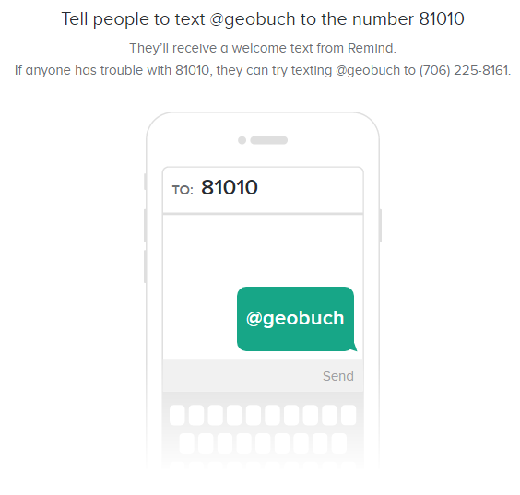
1) grade of zero 2) email parent 3) referral to Mr. Laney

9.) Communication: Please sign up for the class remind messages. Both students and parents are encouraged to sign up. Directions can be found on the class website or in the picture to the right.

Class Website: NHSBUCHANAN.WEEBLY.COM

Please visit and familiarize yourself with the site.

Northside High School
GSE Geometry
Parent Information
August 8, 2019

Dear Parents,

I am looking forward to working with you and your child this school year. In this course your child will develop mathematical skills as directed by the Georgia Standards of Excellence (GSE) and a strong appreciation for the content in the GSE Geometry curriculum. To ensure your student is organized and well prepared in the GSE Geometry class, a three ring binder is required. A scientific calculator is necessary for success and highly recommended (for home). Also, divider tabs and notebook paper is required.
Students must earn 70% or better to receive credit for this course. Progress reports are issued half way through each nine weeks grading period and report cards will reflect the student’s grade at the end of each nine weeks. In addition, you can view your child’s grades, class assignments and attendance using the Parent Portal. You can activate your account by downloading the parent portal app. Please visit our guidance office with any questions. I recommend that you regularly check the portal so you are informed about your student’s progress. A successful completion of GSE Geometry is a requirement for graduation for your student. Please also use the class website to find helpful information. NHSBUCHANAN.WEEBLY.COM
We have read classroom policies, expectations and grading procedures with your child and they will become a permanent part of their notebook to refer as necessary. Please read the policies with your student to ensure a complete understanding of what is expected of them in GSE Geometry. If you have any questions please feel free to contact me at any time by email. Let’s have a productive year!

Sincerely,
David Buchanan
GSE Geometry

I have read and understand the class policies, expectations and grading procedures for GSE Geometry.

STUDENT NAME___________________________ DATE_________________

PARENT NAME____________________________ DATE_________________

PARENT SIGNATURE________________________________________________

E-MAIL ADDRESS__________________________________________________

Class website: NHSBUCHANAN.WEEBLY.COM

