Northside High School 2018-2019 School Year

GSE Algebra II

Teacher: David Buchanan Room: 914
Email: Buchanan.David.W@muscogee.k12.ga.us Phone: 706-748-2920

Website: nhsbuchanan.weebly.com

Course Description: Algebra II/Advanced Algebra is the culminating course in a sequence of three high school courses designed to ensure career and college readiness. It is designed to prepare students for fourth course options relevant to their career pursuits. The course is made up of the following seven units:

Unit 1: Quadratics Revisited Unit 2: Operations with Polynomials
Unit 3: Polynomial Functions Unit 4: Rational and Radical Relationships
Unit 5: Exponential and Logarithmic Functions Unit 6: Mathematical Modeling
Unit 7: Data Analysis

The standards for the class can be found at https://georgiastandards.org I also encourage you to examine Georgia’s Department of Education website: http://www.doe.k12.ga.us/. This website provides a large amount of information, including curriculum and testing.

Grading Procedures: Total Points - 100% of the grade is determined by quizzes, exams, performance tasks, classwork/homework assignments and deductive reasoning activities.

Extra Help: Extra help is available with an appointment. However, Mu Alpha Theta, the honors math club, will provide free tutoring every Tuesday and Thursday (subject to change) from 3:30 to 4:30 in room 932. Also, please utilize my class website for additional help. nhsbuchanan.weebly.com

Important Dates: 1st Nine Weeks: October 18th – Report Card 2nd Nine Weeks: January 15th – Report Card 3rd Nine Weeks: March 21st – Report Card 4th Nine Weeks: May 28th – Report Card

Class Rules / Expectations / Policies / Procedures:
1. Prepared and Organized: Students are expected to come to class to learn.
Daily requirements include *Notebook (3 ring binder)
*Pencils and Erasers is a requirement over the use of pens
*Loose Leaf Notebook Paper
*Dividers
*Graph Paper (if desired not required)
***Calculators for home use are strongly recommended! TI-30XS will be provided in class. This calculator is around $10-$15.*** (Texas Instruments TI-30XS MultiView Scientific Calculator)

2. Academic Honesty Statement: Students will write the following statement/code at the top of their individual work: “I completed this assignment without giving or receiving unauthorized help, thereby maintaining my integrity.” If a student violates this code when written at the top of their work, a zero will be given for the grade, a referral will be sent, and parents notified.

3. Make-Up Work: Students have three days in which to make up all work missed due to any excused absence. Students are responsible for getting the assignment and/or making arrangements for after school testing. Failure to make up work will result in a grade of zero on the assignment and/or test. Being absent the school day before a previously scheduled test does not excuse the student from taking the test on time. Please see NHS student handbook for more details.

(Continued on back…)

4. Attendance: Good attendance is encouraged and expected. Read the MCSD policy for a detailed description of attendance policies.

5. Tardy: A student is considered tardy if he/she is not in his/her assigned seat when the tardy bell rings. The first two unexcused tardies are “free” but central detention will be assigned beginning with the third unexcused tardy. Consequences will escalate if tardies continue.

6. Discipline: Students are expected to be familiar with and adhere to all rules and regulations of the Muscogee County School District Policies. The most important concept to remember is respect:
* Respect for other students
* Respect for teachers, administrators, and any other school personnel
* Respect for school property and furnishings
* Respect for yourself

7. Textbook: HMH Algebra 2 will be used as a resource this school year. All students will have online access to the text book along with online interactive resources. If the student or parent wishes he/she may check out a textbook from the teacher to use for the course. Students will have access to a classroom set of textbooks.

8. Remind: I will be using the system Remind to help communicate with students and parents. It is a one way text message that I will use to remind students of HW, Test, Quizzes, and any other important things. I encourage parents and students to sign up. Text “@alg2buch” to the number “81010” and follow the instructions that are given. Also, you can visit my website, nhsbuchanan.weebly.com and look for the Remind tab and follow instructions there or see image below

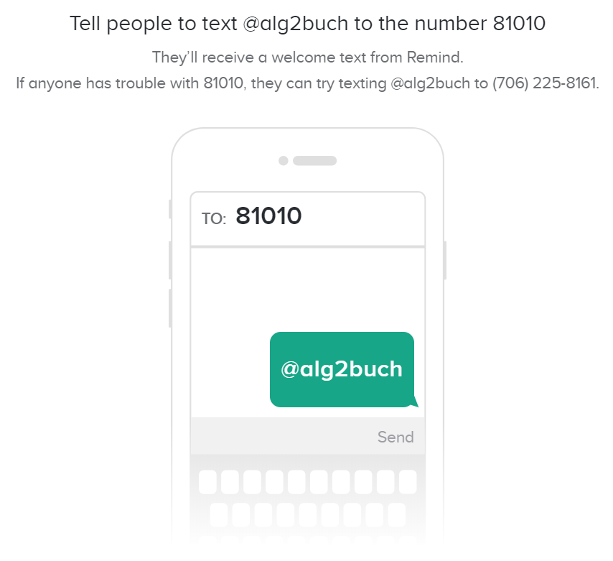

Northside High School
GSE Algebra II
Important Parent Information

Dear Parents,

I look forward to working with you and your child this school year. Pacing is extremely important so that all of the topics are adequately covered prior to the end of the year. Attendance is a priority so please make sure your student makes every attempt to attend class every day. A 3-ring notebook is a requirement for class, and we encourage you to participate in your child’s learning by ensuring that his/her math notebook is kept updated and organized. Progress reports can be viewed on the student portal and will be updated on a regular base so that you can follow his/her development. Calculators are an advantage to your student and highly recommended. The use of the calculator in class is an important part of GSE Algebra II. The calculator we will be using is the Ti30xs Multi View. There is also a picture on the class website.

Class Website: I will be utilizing a class website this year and encourage you to visit and become familiar with it. I will post a variety of things to this website as well as helpful links & video content. It also has all my contact information. nhsbuchanan.weebly.com

Communication: Please make sure to sign up for the Remind message system. You and your child can both join the communication system. Please see syllabus for how to join or visit the class website.

Included are our classroom policies, expectations, class requirements and grading procedures. Please reread the policies with your student to ensure a complete understanding of what is expected of them in GSE Algebra 2. Please feel free to contact me at any time. The number at Northside is 706-748-2920 or email me at buchanan.david.w@muscogee.k12.us.ga

Sign the attachment and return it to school as soon as possible for the first 5 pts of the year! If we all work together, we can make it a very productive school year!

Sincerely,
David Buchanan
GSE Algebra II

Northside High School
2002 American Way
Columbus, Georgia 31909
706-748-2920

I’ve read and understand the syllabus for Coach Buchanan’s GSE Algebra II class.

Date: ___________________________
Student Printed Name: ________________________________________________________
Student Signature: __________________________________________________________
Parent Printed Name: ________________________________________________________
Parent Signature: ____________________________________________________________
Parent E-Mail Address: _______________________________________________________
Daytime Phone Number: ______________________________________________________
*Important Information to Remember

Please make sure your student is present in class to avoid any confusion with the material. Math is always building on prior material so if your student begins to feel confused, after school tutoring is available.
Mu Alpha Theta tutoring will meet Tuesday and Thursday from 3:30 to 4:30 in room 932.

Class Website: nhsbuchanan.weebly.com

Khan Academy: We are going to utilize Khan Academy as a learning tool for any homework questions. Students can make use of the extensive library of content, including interactive challenges, assessments, and videos from any computer with access to the web. The website can be retrieved at www.khanacademy.org.math.

Thank you for your time.

